# Project Phase 1

Alerts phase

* Project Structure.

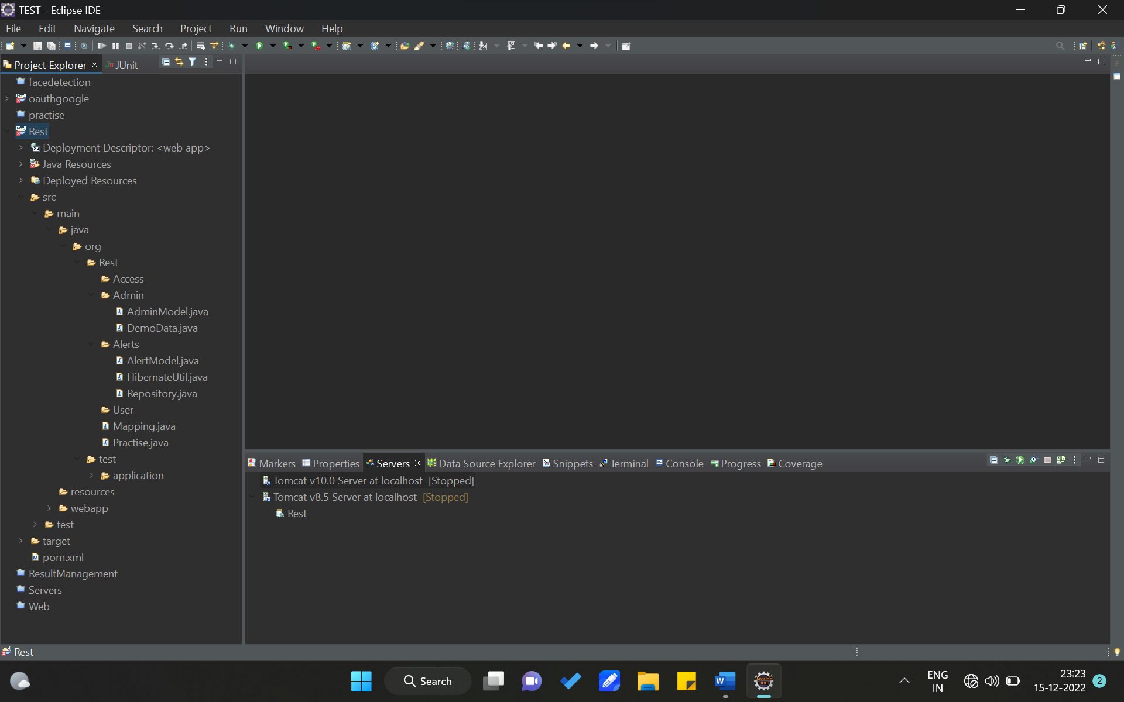

Server Tomcat

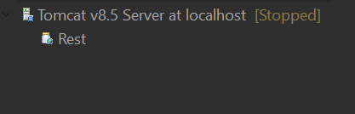

* Technologies

1. URL Endpoint binding
2. JSON and XML Data response and request (LIGHT WIEGHT)
3. Authentication and authorization using API KEY’s
4. Non using RMI (REMOTE METHOD INVOCATION)
5. Containerization using Docker.

* Requirements

1. Java 18 JDK
2. Tomcat 8.5 specific
3. Postman testing
4. Hibernate
5. Java JAX RS
6. Postgres database system

* Dependencies
* End points.

1. Get All alerts GET | <http://localhost:8080/Rest/api/getallalerts/> 🡪no auth
2. Get single alert GET | 🡪no auth
3. Update alert GET | 🡪auth
4. create new alert POST | 🡪auth
5. Delete alert DELETE | 🡪auth

* Database Mapping.
* Database Model’s
* Database configuration Hibernation
* Testing

Get of all alerts

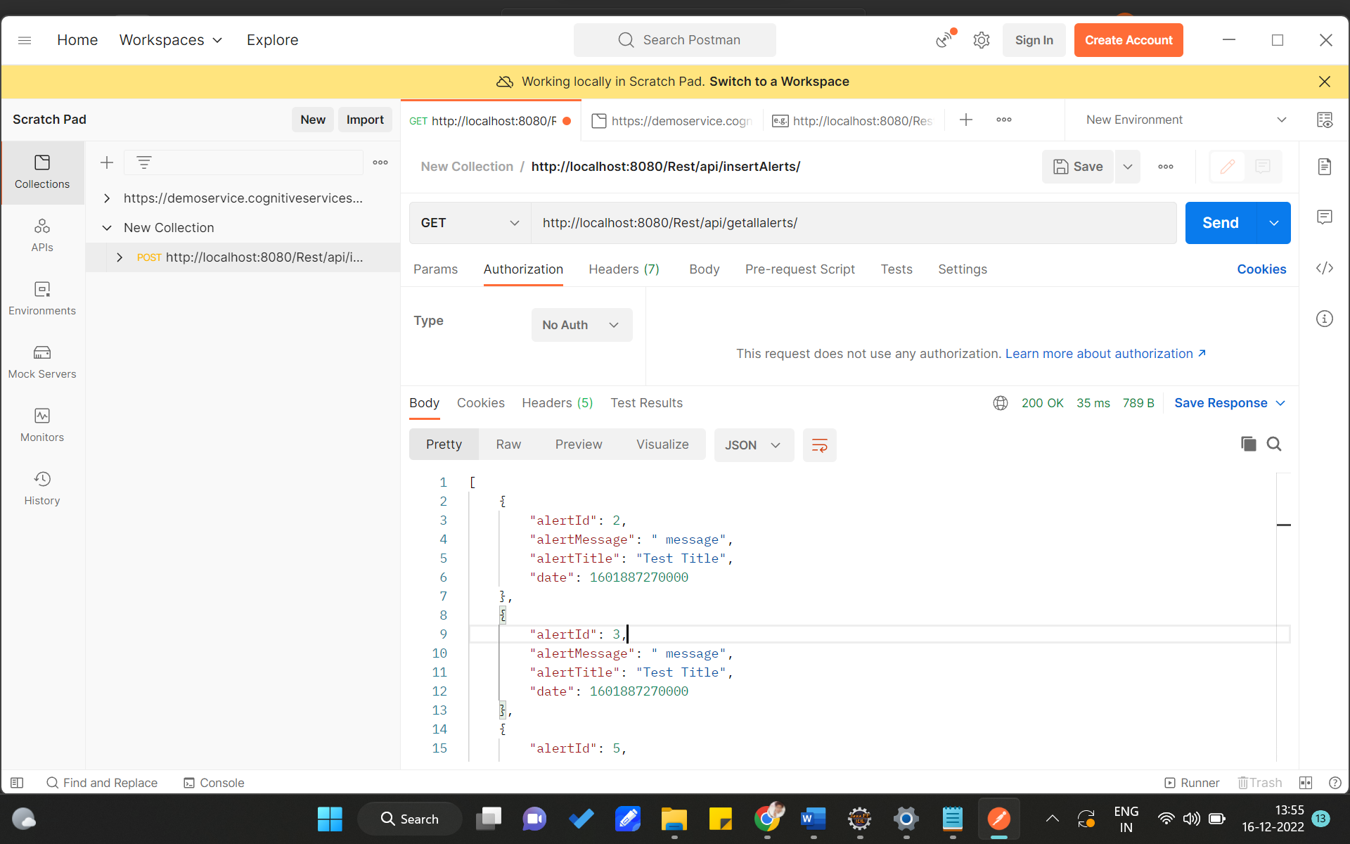

* Deployment

# Project Phase 2

Project Structure